Quick DigitalSignature GUI
Version 1.9
Software User Documentation
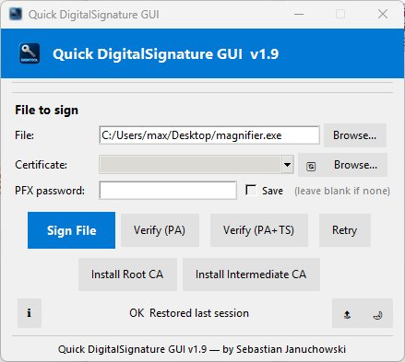
Author | Sebastian Januchowski
Company | polsoft.ITS™ Group
Contact | polsoft.its@fastservice.com
Website | https://github.com/seb07uk
Copyright | 2026 © polsoft.ITS™. All rights reserved.
Document date | March 2026

1. Overview
Quick DigitalSignature GUI is a compact graphical interface for Microsoft's SignTool.exe utility. It allows developers and system administrators to digitally sign Windows executables (.exe, .dll, .msi, .cab) using a PFX certificate, and to verify existing signatures — all through a simple point-and-click workflow that eliminates the need for command-line knowledge.
The application supports SHA-256 signing, RFC 3161 timestamp verification, DPAPI-secured password storage, drag-and-drop file selection, dark/light themes, and automatic session restoration.

2. System Requirements
Requirement | Details
Operating System | Windows 10 or Windows 11 (64-bit recommended)
Python Runtime | 3.8 or later (only required when running from source)
SignTool.exe | Bundled EXE, same folder, Windows SDK, or system PATH
Python Libraries | Pillow, tkinterdnd2 (source only)
Disk Space | < 5 MB
Internet Connection | Required only for Verify (PA+TS) — RFC 3161 timestamp check

3. Installation

3.1 Pre-built EXE (Recommended)
- Download the latest QuickDigitalSignature.exe from the Releases page.
- Place it in any folder alongside your .pfx certificate files (or in a certs\ subfolder).
- Double-click to launch — no Python installation is required.

3.2 Running from Source
- Clone or download the repository from https://github.com/seb07uk.
- Install dependencies: pip install Pillow tkinterdnd2
- Run the application: python Quick_DigitalSignature.py

4. Features
Feature | Description
Sign File | Signs a Windows binary using SHA-256 with the selected PFX certificate.
Verify (PA) | Verifies the digital signature against the local certificate store.
Verify (PA+TS) | Verifies signature and RFC 3161 timestamp via an online authority.
Retry | Repeats the last Sign or Verify operation instantly.
Secure Password | Saves the PFX password encrypted with Windows DPAPI (user- and machine-bound).
Auto Certificate Scan | Automatically discovers .pfx files in the program folder and certs\ subfolder.
Drag & Drop | Drag any file directly onto the application window to select it.
Install Root CA | Installs a root certificate (.cer/.crt) into the Trusted Root store.
Install Intermediate CA | Installs an intermediate certificate into the Intermediate CA store.
Dark / Light Theme | Toggles between themes; preference is saved across sessions.
Always on Top | Pins the window above all other windows.
Session Restore | Restores the last used file, certificate, and password on startup.
Rotating Log | Writes app.log (max 1 MB × 5 backups) for troubleshooting.

5. Usage

5.1 Signing a File
- In the File field, click Browse… or drag-and-drop the target binary.
- Select a certificate from the Certificate dropdown or click Browse… to locate a .pfx file manually.
- Enter the PFX password (leave blank if none). Check Save to store it securely via DPAPI.
- Click Sign File. A confirmation dialog appears on success with the SignTool output.

5.2 Verifying a Signature
Select the signed file using Browse… or drag-and-drop. Then click:
- Verify (PA) — validates the signature against the local certificate store.
- Verify (PA+TS) — additionally validates the RFC 3161 timestamp online.

5.3 Installing Certificates
If verification fails with an untrusted root certificate error:
- Click Install Root CA and select the root .cer or .crt file.
- If applicable, click Install Intermediate CA for any intermediate certificates.
Note: Installing into the Local Machine store requires Administrator privileges. Without elevation, certificates are installed in the Current User store only.

6. Configuration & Logs
Item | Location
Configuration file | %APPDATA%\QuickDigitalSignature\config.json
Log file | %APPDATA%\QuickDigitalSignature\app.log
Log rotation | Max 1 MB per file, 5 backup copies retained
The application automatically saves and restores: last used file path, last used certificate, encrypted PFX password (if Save is checked), and UI theme preference.

7. Troubleshooting
Problem | Solution
SignTool.exe not found | Place signtool.exe next to the application, or install the Windows SDK and add its bin path to the system PATH.
Signature verification fails (untrusted root) | Use Install Root CA and Install Intermediate CA to import the signing chain, or use certmgr.msc / PowerShell Import-Certificate.
Save password is greyed out | Windows DPAPI is unavailable for this user session. Enter the password manually each run.
Certificate not appearing in list | Click the Refresh (🔄) button or use Browse… to locate the .pfx file manually.
Application window disappears behind others | Enable Always on Top using the 🔝 button in the status bar.

8. License & Contact
Copyright © 2026 polsoft.ITS™. All rights reserved. Unauthorized copying, distribution, or modification is prohibited without written permission from the author.
Author: Sebastian Januchowski
Contact: polsoft.its@fastservice.com
Website: https://github.com/seb07uk

